**EXISTING FLOOD CONTROL STRUCTURES**

**1. HIRAKUND DAM**

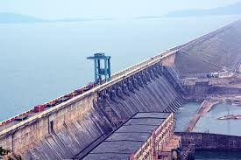

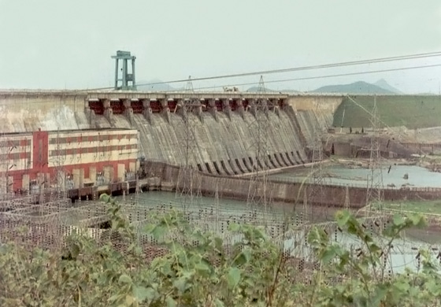

The only existing reservoir scheme for flood control measures across Mahanadi is the Hirakud dam. This is a multipurpose project where irrigation and power generation are other important benefits in addition to flood control benefit. But strangely, there is no storage earmarked for flood control. The FRL and MWL are kept same (630 ft. RL). The flood storage is obtained through the operation schedule (rule curve). The operation schedule approved by the Central Water Commission never allows the reservoir to be sufficiently at lower level to absorb the inflow from the U/s catchment of 83,400 sq. km, especially if the flood hits late in monsoon. The live storage is rather small for such a large catchment. The safety of the dam is always endangered when the inflow approaches the PMF value.

***STRUCTURES*** –

The Hirakud Dam is a composite structure of earth, concrete and masonry. 10 km (6 mile) north of Sambalpur, it is the longest major earthen dam in Asia, measuring 25.8 km (16 mile) including dykes, and stands across the river Mahanadi. The main dam has an overall length of 4.8 km (3 mile) spanning between two hills; the Lamdungri on the left and the Chandili Dunguri on the right. The dam is flanked by 21 km (13 mile) of earthen dykes on both the left and right sides, closing the low saddles beyond the adjoining hills. The dam and dykes together measure 25.8 km (16 mile). It also forms the biggest artificial lake in Asia with a reservoir holding 743 km2 (287 sq. mile) at full capacity, with a shoreline of over 639 km (397 mile). There are two observation towers on the dam one at each side. One is "Gandhi Minar" and the other one is "Nehru Minar". Both the observation towers present breath-taking views of the lake.

Salient features of Hirakud reservoir

|  |  |
| --- | --- |
| Elevation at FRL | 192.024 m |
| Elevation at DSL | 179.830 m |
| Gross storage capacity | 8,136 Mm3 |
| Live storage capacity | 5,818 Mm3 |
| Dead storage capacity | 2,318 Mm3 |
| Water spread area at FRL | 719.63 km2 |
| Length of the masonry dam | 1,248 m |
| Number of sluices | 64 |
| Number of crest gates | 34 |
| Crest level of spillway dam | 185.928 m |
| Maximum spillway capacity | 41,428 cumec |

***POWER HOUSE*** –

The dam supports two different hydroelectric power houses. Power House I is located at the base (toe) of the main dam section and contains 3 x 37.5 MW Kaplan turbine and 2 x 24 MW Francis turbine generators for an installed capacity of 259.5 MW. Power Station II is located 19 km (12 mile) southeast of the dam 21°21′10″N 83°55′00″E at Chipilima. It contains 3 x 24 MW generators. The entire installed capacity of the dam's power houses is 307.5 MW. Power House I and II were built in three stages. During stage I, four generators were installed at PH I and in stage II, the power channel two and Power House II was constructed. All three generators were installed at PH II along with two more at PH I by 1963. Between 1982 and 1990, the seventh and final generator was installed at PH I.

***PURPOSE OF THE DAM*** –

In the upper drainage basin of the Mahanadi River, cantered on the Chhattisgarh Plain, periodic droughts contrast with the situation in the lower delta region where floods may damage crops. The dam was constructed to help alleviate these problems by creating a reservoir and controlling river flow through the drainage system. The dam regulates the flow of the Mahanadi River and produces hydroelectricity through several hydroelectric plants.

The dam helps control floods in the Mahanadi delta and irrigates 75,000 square kilometres of land. Hydroelectricity is also generated. The Hirakud Dam regulates 83,400 km² (32,200 mi²) of Mahanadi's drainage. The reservoir has a storage capacity of 5.818 km³ with gross of 8.136 km³.

It drains an area of 133,090 km², more than twice the area of Sri Lanka. The amount of earth, concrete and masonry materials used to build the dam is sufficient to make a road 8 metres wide and pave it from Kanyakumari to Kashmir and from Amritsar to Dibrugarh in Assam. With successful irrigation provided by the dam, Sambalpur is called the rice bowl of Odisha.

The project provides 1,556 km² of kharif and 1,084 km² of rabi irrigation in districts of Sambalpur, Bargarh, Bolangir, and Subarnpur. The water released by the power plant irrigates another 4360 km² of CCA in Mahanadi delta. The dam can generate up to 307.5 MW of electrical power through its two power plants at Burla, on the dam's right bank and Chiplima, 22 km downstream from the dam. In addition, the project provides flood protection to 9500 km² of delta area in district of Cuttack and Puri.

Chiplima has gained prominence as the second hydroelectric project of the Hirakud Dam. A natural fall of 80 to 120 feet (25 to 40 m) in the river Mahanadi is used to generate electricity. The place is mostly inhabited by fisherman, whose deity Ghanteswari is very popular in the neighbouring area. The State Livestock Breeding Farm and Agricultural Farm are located here.

**2. RIVER EMBANKMENTS**

Mahanadi gets divided into several branches at the head of delta. Due to a very flat slope towards the outfall, sediments carried by these rivers get deposited in the bed raising the river bed in course of time. The present situation is such that the rivers now flow in high ground and the surrounding area is lower than the river bed. In order to protect the habitation and the agricultural land the rivers are banked on both sides. The embankments are designed to withstand a discharge of at the head of delta. The embankments are deficient in several counts.

They are not continuous. There are wide gaps at several places. They are not of uniform standard. Some are capital embankments, some are other agricultural embankments, some are test relief embankments and some are gharry bunds. The four categories have separate specifications.

They are not properly designed. Most of them are deficient in slope and lack proper elevation at places. They are very poorly maintained.

**EXISTING FLOOD MANAGEMENT**

Flood management in Mahanadi is mostly depends on the reservoir operation of Hirakud. Chief Engineer in charge of Hirakud dam is responsible for the operation whereas the general flood management is in charge of another CE. Secy, DoWR and EIC oversee the management.

***Data Collection Network***

There are 50 G &D and rain gauge sites in the Hirakud catchment maintained by the Mahanadi Division of Central Water Commission. There are also 22 downstream stations which provide hydro-meteorological information. The state Government also maintained 7 seasonal rainfall and discharge stations u/s of Hirakud.

Data in all these stations are collected manually. These are transmitted by voice communication and HF wireless sets.

***Estimation of inflow flood hydrograph***

Unit hydrograph technique is used for the purpose of flood forecasting. The entire u/s basin has been divided into four sub basins like

• Mahanadi Sub-basin up to Saradihi (61,030 km2)

• Ib sub-basin upto Deogaon (82397 km2)

• Mond Sub-basin upto Tarapur (4740 km2)

• Ungauged Catchment (9391 km2)

Unit hydrographs (24 hrs and 1 inch) have been developed for these sub-basins. From the available rainfall data weighted rainfall is estimated by Thiessen polygon method. Effective rainfall is estimated by taking it as a fraction of the total rainfall basing on three-day rainfall and month of the rainfall as experienced in the past events. By superimposing the unitgraph over the effective daily rainfall, inflow flood hydrograph is estimated and updated.

***Drawbacks of the existing forecasting system***

Manual collection of information involves human error and consumes time. Data transmission mechanism is unreliable and more so at the time of cyclone and flood . The existing data communication mechanism is time consuming. Considering a single UG for a big catchment unit area up to 60,000 km2 involves error. Process of estimation of effective rainfall error. Considering these facts it is observed that there is enough scope for development in the existing flood forecasting mechanism.